22nd May 2023

WPT Assignment 1

Problem statement-1 : Create your resume page as per the format shown in the figure on LHS.

<!DOCTYPE html>

<html lang="en">

<head>

<meta charset="UTF-8">

<meta http-equiv="X-UA-Compatible" content="IE=edge">

<meta name="viewport" content="width=device-width, initial-scale=1.0">

<title>Abhijeet's Resume</title>

</head>

<body>

<!-- aligns and underline -->

<h1 align='center'><u>Resume</u></p>

<br>

<h3><i>Abhijeet Singh</i></h3>

<p><i>Address 2</i></p>

<p><i>Address 3</i></p>

<p><i>Address 4</i></p>

<p><i>Mobile No:123456</i></p>

<p><i><b>Email:</b>email@email.com</email></i></p>

<hr>

<h2>Educational Qualification</h2>

<table width="100%">

<thead>

<tr align="left">

<th>Qualification</th>

<th>Institute</th>

<th>University</th>

<th>Marks</th>

<th>Year of Passing</th>

</tr>

<tr>

<td>Btech</td>

<td>IIT</td>

<td>IIT</td>

<td>100</td>

<td>2022</td>

</tr>

<tr>

<td>HSC</td>

<td>DPS</td>

<td>DPS</td>

<td>100</td>

<td>2018</td>

</tr>

<tr>

<td>SSC</td>

<td>DPS</td>

<td>DPS</td>

<td>100</td>

<td>2016</td>

</tr>

</thead>

</table>

<h2>Skill Set:</h2>

<table width="40%">

<tr align="left">

<th>Operating Systen</th>

<td>Windows 9, Dos</td>

</tr>

<tr align="left">

<th>Language</th>

<td>c/c++</td>

</tr>

<tr align="left">

<th>Front-End</th>

<td>VB 6.0</td>

</tr>

<tr align="left">

<th>DBMS</th>

<td>Oracle</td>

</tr>

</table>

</body>

</html>

OUTPUT

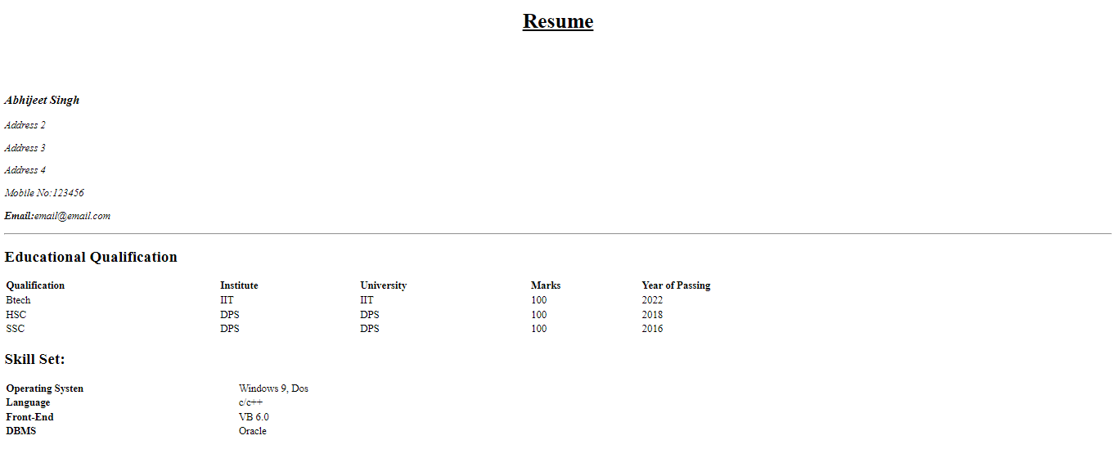

Problem statement-2 : Create a web page to display a list as shown in the figure on RHS:

Code:

<!DOCTYPE html>

<html lang="en">

<head>

<meta charset="UTF-8">

<meta http-equiv="X-UA-Compatible" content="IE=edge">

<meta name="viewport" content="width=device-width, initial-scale=1.0">

<title>Listing</title>

</head>

<body>

<ol type="1">

<li>Language

<ol type="i">

<li>English

<ol type="A">

<li>Prose</li>

<li>Poetry</li>

</ol>

</li>

<li>Hindi

<ol type="A">

<li>Prose</li>

<li>Poetry</li>

</ol>

</li>

<li>Marathi

<ol type="A">

<li>Prose</li>

<li>Poetry</li>

</ol>

</li>

</ol>

</li>

<li>Social Study

<ol type="i">

<li>History</li>

<li>Geography</li>

</ol>

</li>

<li>Science

<ol type="i">

<li>Physics

<ol type="A">

<li>Part1</li>

<li>Part2</li>

</ol>

</li>

<li>Chemistry

<ol type="A">

<li>Organis</li>

<li>Inorganic</li>

</ol>

</li>

<li>Biology

<l type="A">

<li>Botany</li>

<li>Zoology</li>

</ol>

</li>

</ol>

</li>

<li>Maths

<ol type="i">

<li>Algebra</li>

<li>Geometry</li>

</ol>

</li>

</ol>

</body>

</html>

Output

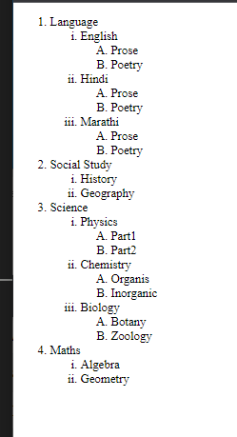

Problem statement-3-a : Create a web page to display tables as shown in the figures below. Clicking on link should lead the user to another document that displays a brief description of the book and review comments.

Code

<!DOCTYPE html>

<html lang="en">

<head>

<meta charset="UTF-8">

<meta http-equiv="X-UA-Compatible" content="IE=edge">

<meta name="viewport" content="width=device-width, initial-scale=1.0">

<title>Book review</title>

</head>

<body>

<table width="50%" border="2px">

<thead>

<th>Book Title</th>

<th>Author</th>

<th>Book Price</th>

</thead>

<tr>

<td><a href="https://www.google.com">Core Java</a></td>

<td>Cay Horstman</td>

<td>400</td>

</tr>

<tr>

<td><a href="https://www.google.com">Beginning Java</a></td>

<td>Ivar Horton</td>

<td>600</td>

</tr>

<tr>

<td><a href="https://www.google.com">Learning Java</a></td>

<td>Kishori Shahane</td>

<td>400</td>

</tr>

<tr>

<td><a href="https://www.google.com">Java Cookbook</a></td>

<td>John Keller</td>

<td>800</td>

</tr>

</table>

</body>

</html>

Output

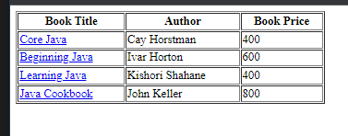

Problem statement-5: Create a web page to display a table as shown in the figure below.

Code

.

<!DOCTYPE html>

<html lang="en">

<head>

<meta charset="UTF-8" />

<meta http-equiv="X-UA-Compatible" content="IE=edge" />

<meta name="viewport" content="width=device-width, initial-scale=1.0" />

<title>Document</title>

<link rel="stylesheet" href="empcss.css" />

</head>

<body>

<table>

<tr>

<td>name</td>

<td><input type="text" /></td>

</tr>

<tr>

<td>Employee Code</td>

<td><input type="text" /></td>

</tr>

<tr>

<td>Department</td>

<td>

<input type="radio" value="Admin" />

<label for="Admin">Admin</label><br />

<input type="radio" value="HR" />

<label for="HR">HR</label><br />

<input type="radio" value="Technical" />

<label for="Technical">Technical</label><br />

<input type="radio" value="Accounts" />

<label for="Accounts">Accounts</label><br />

</td>

</tr>

<tr>

<td>Date of Joining</td>

<td>

<input type="date" />

</td>

</tr>

<tr>

<td>Address</td>

<td><textarea rows="5" cols="40"></textarea></td>

</tr>

<tr>

<td>Training Programs Attended</td>

<td>

<input type="checkbox" value="HTML" />

<label for="">HTML</label><br />

<input type="checkbox" value="Java" />

<label for="">Java</label><br />

<input type="checkbox" value="Client" />

<label for="">Client</label><br />

<input type="checkbox" value=".net" />

<label for="">.net</label>

</td>

</tr>

<tr>

<td>Training Programmes need to attend</td>

<td>

<select name="Programmes">

<option value="Javascript">Javascript</option>

<option value="CSS">CSS</option>

<option value="JSBC">JDBC</option>

</select>

</td>

</tr>

<tr>

<td>Send info to given email</td>

<td>

<a href="mailto:kiranfand01@gmail.com">kiranfand01@gmail.com</a>

</td>

</tr>

</table>

</body>

</html>

CSS

table, th, td {

border: 2px solid black;

border-collapse: collapse;

background-color: pink;

}

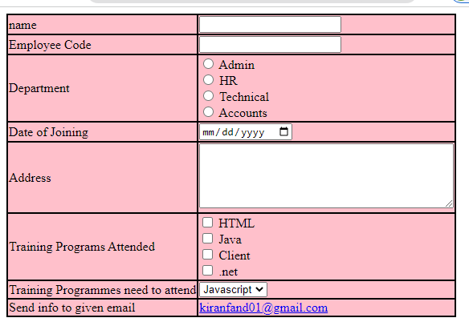

Problem statement 8: Create an online form to gather feedback from the users on problems or difficulties they have faced while purchasing items in a sports website. The information of the client will be sent via email to an email address pre-established in the source code of the online form.

Code

HTML

<!DOCTYPE html>

<html lang="en">

<head>

<meta charset="UTF-8">

<meta http-equiv="X-UA-Compatible" content="IE=edge">

<meta name="viewport" content="width=device-width, initial-scale=1.0">

<title>FeedBack Form</title>

<link rel="stylesheet" href="styles.css">

</head>

<body>

<h3 align="Center">This form will be used to gather feedback from the users on problems or difficulties they may

have faced while purchasing items in a sports website.</h3>

<h3 align="Center">Please fill carefully</h3>

<p align="center">\* Mandatory</p>

<form action="mailto:dummy@gmail.com" method="post">

<label class="required" for="uname">Username</label><br>

<input type="text" id="uname" name="uname" required><br>

<label class="required" for="email">Email</label><br>

<input type="email" name="email" id="email"><br>

<label for="location">Location</label><br>

<input type="text" id="location" name="location"><br>

<label for="phone">Phone</label><br>

<input type="text" name="phone" id="phone"><br>

<label class="required" for="desc">Description</label><br>

<input type="text" name="desc" id="desc"><br>

<label for="problem-type">Problem Type</label><br>

<input type="text" id="type" name="type"><br>

<label for="status">Status</label><br>

<input type="text" name="status" id="status"><br>

<input type="submit" value="send">

</form>

</body>

</html>

CSS

.required:after {

content: "\*";

color: red;

}

Output

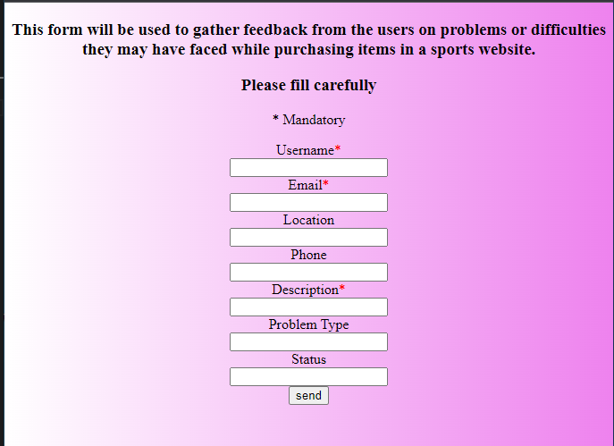

HTML5:

Problem statement-1: Create a HTML5 web page that looks like:

Code

HTML

<!DOCTYPE html>

<html lang="en">

<head>

<meta charset="UTF-8">

<meta http-equiv="X-UA-Compatible" content="IE=edge">

<meta name="viewport" content="width=device-width, initial-scale=1.0">

<title>Appointment Scheduler</title>

<link rel="stylesheet" href="styles.css">

</head>

<body>

<h2>Appointment Scheduler</h2>

<form action="mailto:dummy@gmail.com" method="post">

<fieldset>

<legend>Personal Information</legend>

<label class="required" for="uname">Username</label><br>

<input type="text" id="uname" name="uname" required><br>

<label for="phone">Phone</label><br>

<input type="text" name="phone" id="phone"><br>

<label for="dob">Date of Birth</label><br>

<input type="date">

</fieldset>

<fieldset>

<legend>Appointment required</legend>

<label class="required" for="desc">What is the reason for your visit</label><br>

<input type="text" name="desc" id="desc"><br>

<label for="pain-level">Current Pain level</label><br>

<input type="range" value="5" min="0" max="10" oninput="this.nextElementSibling.value = this.value">

<output>5</output><br>

<label for="adate">Preferred Date</label><br>

<input type="date"><br>

<label for="atime">Prefferd Time</label><br>

<input type="time" name="atime" id="atime">

</fieldset>

<br>

<input type="submit" value="Submit">

</form>

</body>

</html>

CSS

body {

background-image: linear-gradient(to right, white, violet);

}

OUTPUT

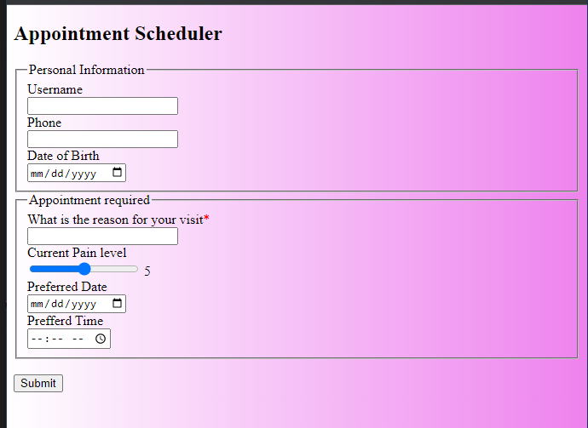

Problem statement-2: Create a HTML5 web page that looks like: (make use of CSS too)

Code

HTML

<!DOCTYPE html>

<html lang="en">

<head>

<meta charset="UTF-8" />

<meta http-equiv="X-UA-Compatible" content="IE=edge" />

<meta name="viewport" content="width=device-width, initial-scale=1.0" />

<title>Appointment Scheduler</title>

<link rel="stylesheet" href="styles.css" />

</head>

<style>

body {

background-color: rgb(87, 87, 121);

}

</style>

<body class="regisform">

<form action="mailto:dummy@gmail.com" method="post" >

<fieldset>

<legend>Registration Details</legend>

<table align="center">

<tr>

<td><label for="uname">University:</label></td>

<td><input type="text" id="uname" name="uname" required /></td>

</tr>

<tr>

<td><label for="institute">Institute:</label></td>

<td><input type="text" name="institute" id="institute" /></td>

</tr>

<tr>

<td><label for="branch">branch</label></td>

<td>

<select name="branch" id="branch ">

<option value="--select--">--select</option>

<option value="ECE">ECE</option>

<option value="MECH">MECH</option>

</select>

</td>

</tr>

<tr>

<td><label for="degree">Degree</label></td>

<td>

<select name="degree" id="degree">

<option value="--select--">--select</option>

<option value="BE">ECE</option>

<option value="BTECH">MECH</option>

</select>

<input type="radio" name="pursuing" id="pursuing" /><span

>Pursuing`</span

>

<input type="radio" name="completed" id="completed" /><span

>Completed</span

>

</td>

</tr>

<tr>

<td><label for="cpi">Average CPI</label></td>

<td>

<input type="number" name="cpi" id="cpi" class="mytext" /><span> Upto </span

><input type="number" name="sems" id="sems" class="mytext" />

<span> TH Semesters </span>

</td>

</tr>

<tr>

<td><label for="exps">Experience</label></td>

<td><input type="number" name="exps" id="exps" class="mytext" /><span> Years</span></td>

</tr>

<tr>

<td>

<label for="blog">Your url or blog</label>

</td>

<td>

<input type="url" name="blog" id="blog" />

</td>

</tr>

</table>

</form>

</body>

</html>

CSS

.required:after {

content: "\*";

color: red;

}

.mytext {

width: 30px;

}

.regisform {

background-color: rgb(91, 178, 218);

}

Output

